Software Engineering Management

Tom Goncin

Table of Contents
Contents
No table of contents entries found.

Recap:
People Centered Design
(ENSE 271)

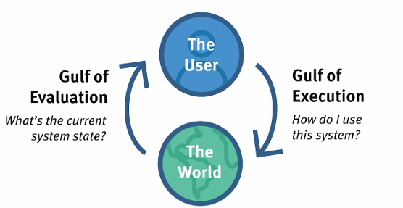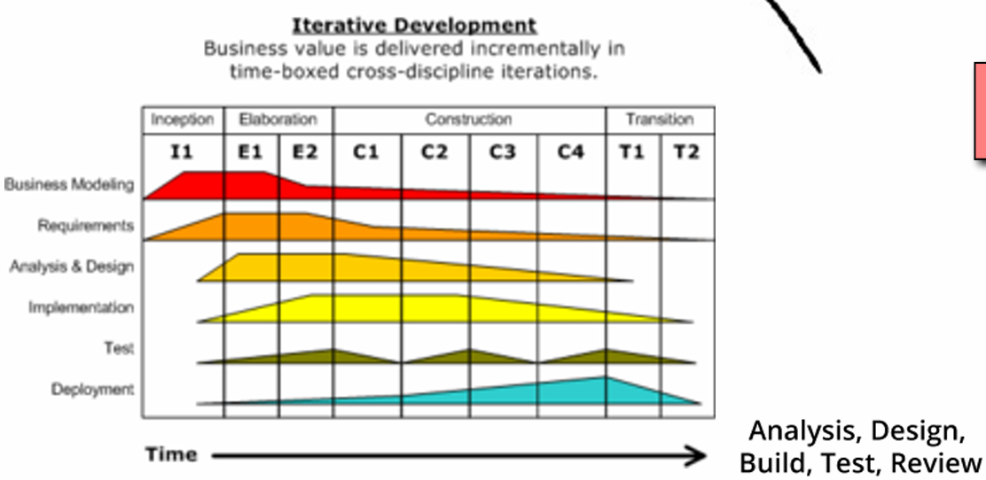
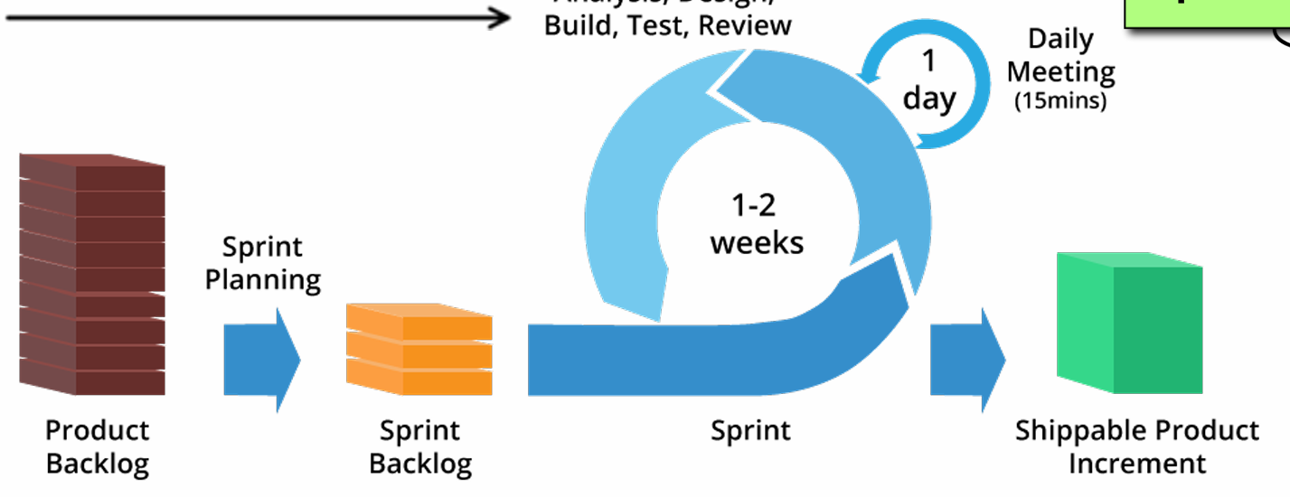
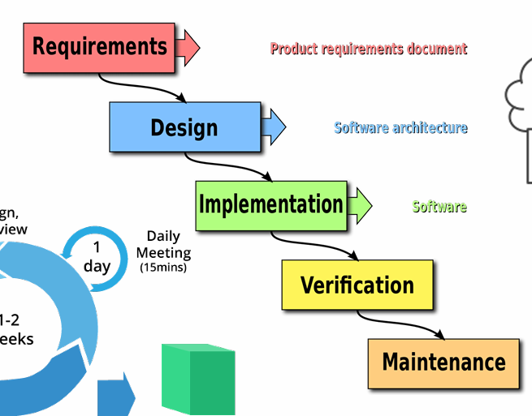
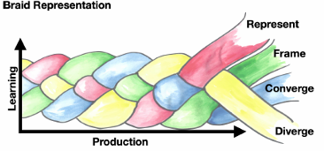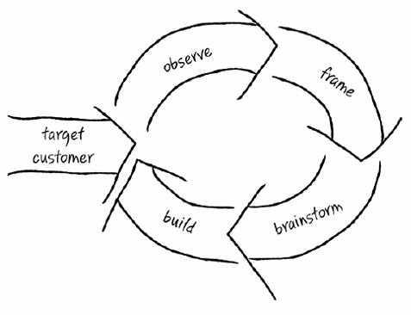
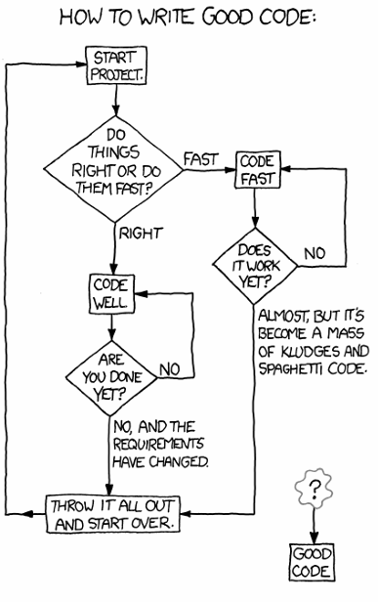

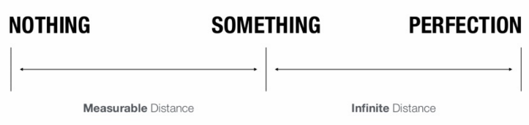

Constraints

Limits | No special training/interpretation | False consensus effect  Cognitive bias – You are not the user  Confirmation Bia – You are not the user
Cultural | Forcing action:  Interlock – proper sequence)  Lock-ins – Keeps operation active until safe to end  Lock-out – Prevents unsafe action from being performed | Legacy
Standards |  | ∆time

Brainstorming

Combining & Recombining:  Converging – Narrowing generated ideas  Diverging – expanding possibilities/alternatives, diversifying ideas | Fresh snow/Tunnel vision  Do lateral jumps
 | Marinate

Visual Techniques
(Get feedback early)

USM | empathy map | H/L fidelity prototyping | State Diagram
flow map | Quiet-storming

User Experience

UX (User Experience)  Discover – Field studies, user/stakeholder interviews, competitive testing, metrics  Explore – Competitive analysis, persona building, task analysis, HCD, card sorting, evidence-based guidelines, repair planning, social implications  Test – Qualitative/Quantitative, user protection, bugs, benchmark testing (competing company, standards, goals, statistics, interpretation is where value resides from report)  Listen – Surveys, statistics, Q&A, FAQ  Be an anthropologist | LEAN:  Eliminating waste  Maximizing value  Continuous improvement
Uncovering user needs

Context inquiry

Observing Customer UI

Usability Heuristics (Simplifying the complex):  • Visible system status  • System & real-world match  • User control & freedom (Undo & Redo)  • Consistency & standards  • Error prevention (Standards)  • Recognition instead of recalling to they work  • Flexibility & use efficiency (Only what user needs)  • Aesthetic & Minimalist design  • User error recognition, diagnosis, & recovery | Likert Scales  • Satisfied  • Simple  • Fun  • Expectations  • Inconsistencies | Fake homepage (LEAN)  Eye tracking test  Usability  • Response test  • Wizard of Oz test
 | Scenario interviews | Concept testing
Quant / Qual  • Qualitative  80% of issues arise within 5 users tested, best for short time frames  • Quantitative  How much, how many (measurable) | Intuition in a sin  Feedback always | Statistical Significance (Quant)  Comparisons  ∆ in 2 values is large = reliable = valuable  Second run should = same result
Usability Comparison | Goal | Heuristics Review | Sample Size
Formative | What Aspects of design  What works or not | Usability testing  Cognitive walkthrough | Can be small  Good in beginning
Informative | Usability compared to given benchmark | Completed product  Client grades criteria/satisfaction | Large  Not quick to learn from  Good overall

Design
(Let humans do what we’re good at & computers to what we’re bad at)

Why, Why, How  • What is the problem?  • Why do you have a problem?  • Why do you think that’s the problem?  • Why is it fundamental?  • How do we work around it?  • What are possibly solutions?  • What solutions are doable | Scaling Up  Scaling up assumptions ∆problem to solve  Theatre  Looks good, but doesn’t work  Good for prototyping | Standardization  Muddling Through  Do analysis  Go where users are (anthropological)  Where within do you need to go  Small steps  Upon failure, no one notices  Upon success, moves further towards goal
Affordances  Objects having qualities that suggests use | Signifiers  Visual/audio ques helping user understand how to interact | Fast Feedback cycle  Feedback Feedforward
Human Technology Collaboration | Focus | Sprints  Milestone development except shorter iterations
Scenario Hierarchies  • Themes  • Vision-level stories  • Task-level stories  • Deliverables  • Bugs | Regular customer interaction  Experience metrics  Prototyping & Documentation | Success Measuring Metrics  End-to-end experience focus (Not features)  Experience Slices:  Business Heath  Customer Experience Health  Technology and system health
K.I.S.S | Initial “ahh” | Complete user journey rather than scenario focused
Change Management | Collaboration | Change Agents
Discoverability  Users realizing actions possible | Business Focused Strategy  Natural Mapping | Threshold  Difficulty to learn  Ceiling  Value provided in possibilities/capabilities
7 Stages of Action | Systems of Cognition  Subconscious – automatic, skilled  Conscious – slow, controlled  Compensatory decision making  (Pro/Con) | Processing Levels  • Reflection – Reasoning  • Behavioral – Pattern matching, subconscious  • Visceral – Limbic system (lizard)
  Goal formation  Planning  Action (Specify)  Perform (sequence) | Perceive  Interpret  Compare

Complexity
(Inevitable-Embrace it: Seek powerful & usable, design rather than features)

Complexity  State of being & how to manage  Complicated  Feeling overwhelmed | User Roles  Learn & Adapt to complex systems = mastery | Layered Complexity  Users can engage with complexity at different levels  Designed for specific needs & Expertise  More manageable
Managing Complexity:  • Desire lines (Tools that force behavior)  • Holistic design & development approach  • Journey Mapping (Actor, scenario, phases, feedback)  • Designer/developer/User collaboration:  • Current-State Value Stream Map:  Existing flow of materials & information  • Future-State Value Stream Map:  Desired flow of materials & information  • Service Planning & Design: (∆s over time, continual)  Service blueprint (checklist): | Cradle to Grave  • Resource consumption  • Energy use  • Emissions  • Waste generation  Gulf of Evaluation  What is current system state  What happens when I do this  Gulf of Execution  How to use this system | People Centered Design  • GESTALT  • Eye tracking for user activity  • Affordances & Signifiers (Can be overdone)  • Defaults  • Learning aids  • Some automation  • Aesthetics & Usage patterns (Natural path)  • Societal & Environmental impacts  • Solid, trailed designs  • K.I.S. S
  In/out-facing: | Standards  Rules  blueprints
  Customer/employee actions  Journey map | Front stage actions  Backstage actions  Support process

Teams & Leadership

Precise language | Collaboration | All else NOT equal  Strengths focused
Communication  Frequent & Clear | Business Focused Strategy

Managing Change
Constant leadership, change agents, middle management resistance, Change management principles,

Pragmatic Philosophy
for
Pragmatic Programmers

Stone Soup:
Entropy:
Boiling Frog:
False Consensus Effect:
Make quality from the users perspective, paramount.

Professional Development
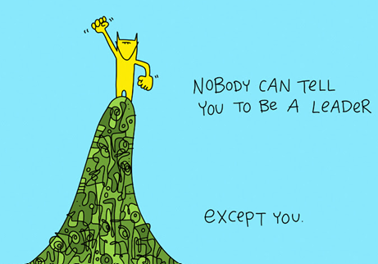
Be a software gardener.
• Level 1: Beginning
• Level 2: Introductory
• Level 3: Competency
• Level 4: Leadership

Linearity:

Communication
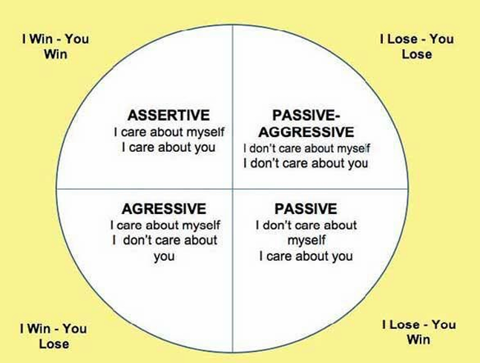

• Know what you want to say
• Know your audience
• Choose your moment
• Choose a style
• Make it look good
• Involve your audience
• Be a listener
• Get back to folks

Understanding the Project Environment

